**Disease Prediction using Natural Language Processing**

**About Team**

1. Name: Deep Thinkers
2. Team Members
   1. Gaurav Kumar Daharia – Associate Software Engineer (Hexaware)
   2. Dhananjay Kumar – Software Developer Engineer (Anuta Networks)

**Problem Statement**

There is a lot of physical problem faced by people during this pandemic, so there is a need of solution where people don’t have to go any where and they can get instant solution for the problem like disease from which they are suffering.

We Team **Deep thinkers** have developed platform for people by using which they can know from which disease they are suffering and what is the cure of it.

**Technology Used**

1. Natural Language Processing
2. Deep Learning
3. FastAPI – used for creating api
4. Bert – opensource data encoder powered by google

**Description**

**How our solution is working on primary care?**

Our solution allows user to share the symptom that they are feeling and based on symptom our prepared model predicts and gives instant solution for it. So, from here we can see that it is proving the primary care to the user in a second.

**How our solution is providing patient support for managing diseases and getting right access to health care?**

Our prepare **Deep Learning Model** is doing both in combined way it not only detects the problem the user have but also shares the suggestion for instant cure of disease. Otherwise user can directly contact to support team more help.

**Working Architecture of Project**

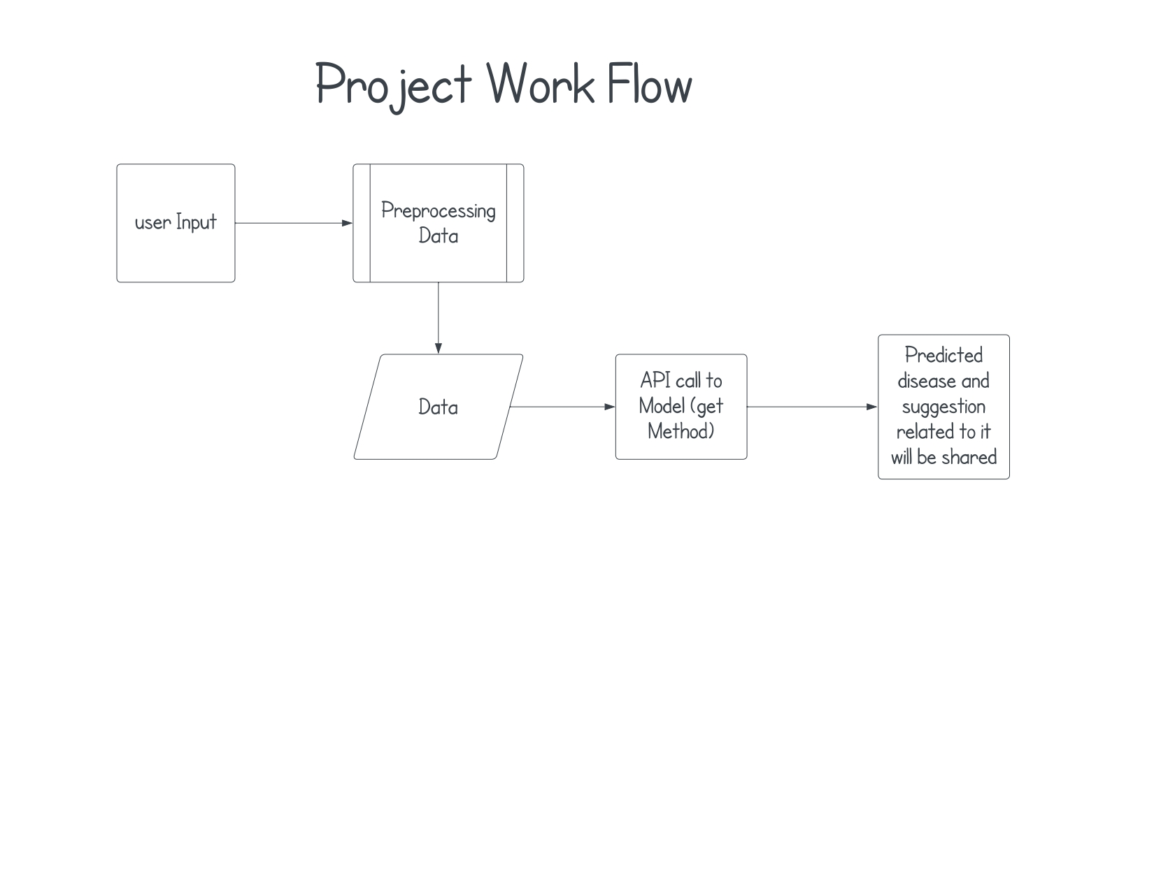

**Model Architecture Used for Predicting disease**

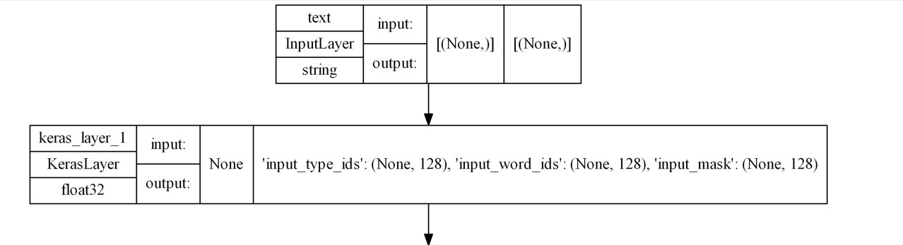



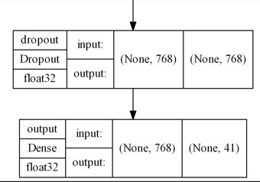

Above picture depicts the model that we have created ,this model uses BERT (**Bidirectional Encoder Representations from Transformers**) it is a type of intellegent encoder which gives a very unique encoding for every text provided by the user, it eventually helps our model to learn each term and allows our user to know from which disease they are suffering and what is cure for it.

**Model Performance Graph**

Model Accuracy Graph

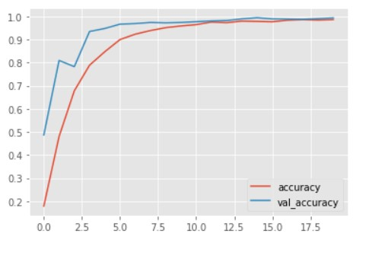

This model has achieved accuracy of 98.54% on training and 99.27 on testing, through this we can see that model is performing well on unseen data. This can also be confirmed from loss graph which shows that model test loss is less than training loss

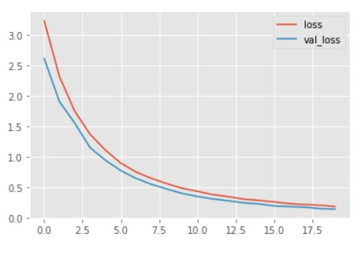

So from above we can see the val_loss(validation loss) is below the loss(training loss).

**API- Application Interface for web usage**

We have also created API so that we can call our model over the network, which eventually opens a new way of using model.

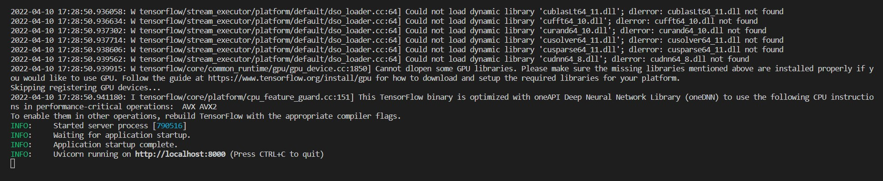

See from above that our api is running and up at port 8000, since we haven’t used any other platform for using it so it is on localhost.

**Small Output Presentation**

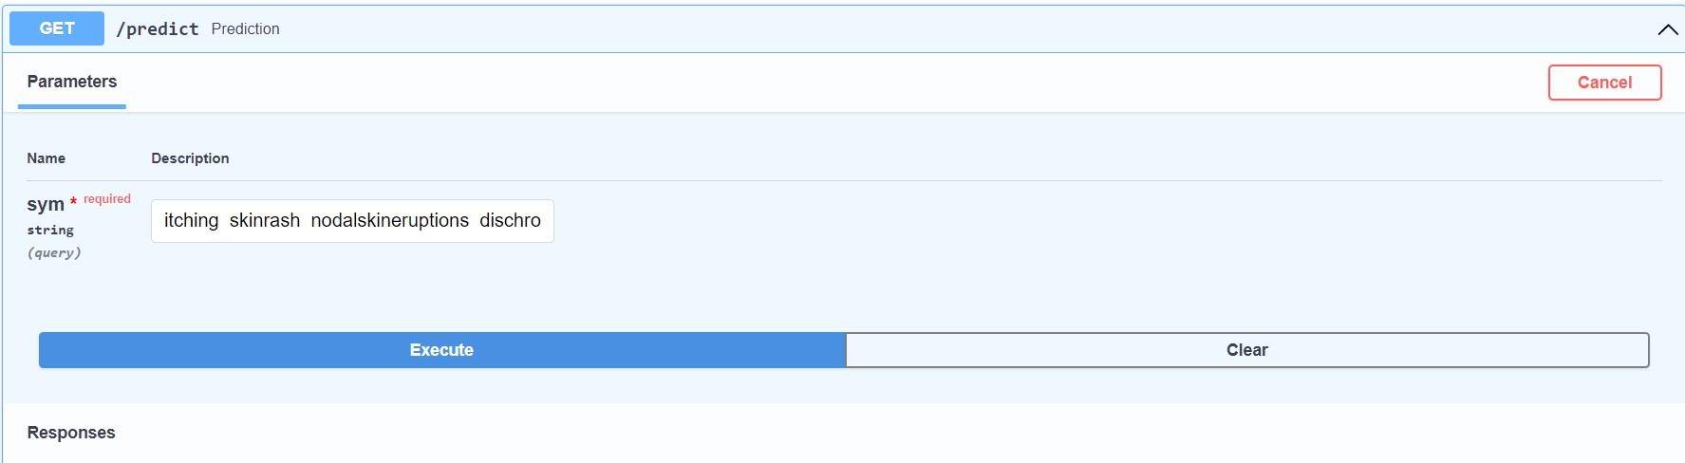

So, we can see we have provided symptom for **fungal infection** in the above section. Now when we hit the execute button then we will see output mentioned below.

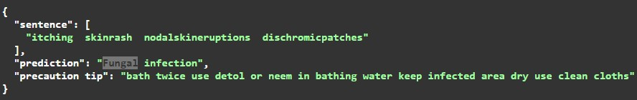

So, from above we can see our model is predicting it is **fungal infection** and it also shares the **precaution tip** to user related to that problem.

EndNote:

1. Please access Project through this like https://github.com/GauravDaharia20/NTTDataAIHack_DeepThinkers.git.
2. Please get model uploaded at following like:” https://drive.google.com/drive/folders/1SCGxIX54SmLU7UedNJYP6FM84L9uUBWK?usp=sharing”
3. To run API please use command “**python main.py”**, you will find API in api folder.
4. We have developed our project till API development, we will be deploying it soon on web.